**PATFIN NURSERY AND PRIMARY SCHOOL, AKESAN, LAGOS STATE.**

**FIRST TERM EXAMINATION [ 2018 / 2019 ]**

**CLASS : HEAD – START**

**NAME : _____________________________ SUBJECT: CHRISTAIN RELIGIOUS STUDIES**

**INSTRUCTION : ANSWER CORRECTLY DURATION : 1 HOUR**

1. Did David kill Goliath with a stone and catapult ? [ Yes / No ]
2. Baby Moses was born in Egypt. [ Yes / No ]
3. Do you love Jesus ? [ Yes / No ]
4. The fist man and woman God ever created was _____________ and _____________.
5. Moses’s mother hid him inside a basket. [ Yes / No ]

**PATFIN NURSERY AND PRIMARY SCHOOL, AKESAN, LAGOS STATE.**

**FIRST TERM EXAMINATION [ 2018 / 2019 ]**

**CLASS : HEAD – START**

**NAME : _____________________________ SUBJECT: KNOWLEDGE OF THE WORLD**

**INSTRUCTION : ANSWER CORRECTLY DURATION : 1 HOUR**

1. We have three[3] major ethnic groups in Nigeria. [ Yes / No ]

* ***STATES AND CAPITALS***

1. Abia 🡺 ___________________________
2. Adamawa 🡺 ___________________________
3. Where do you live?

I live in _______________________________.

1. What is the name of your school?

The name of my school is __________________________________________________.

**PATFIN NURSERY AND PRIMARY SCHOOL, AKESAN, LAGOS STATE.**

**FIRST TERM EXAMINATION [ 2018 / 2019 ]**

**CLASS : HEAD – START**

**NAME : _____________________________ SUBJECT: SOCIAL HABIT**

**INSTRUCTION : ANSWER CORRECTLY DURATION : 1 HOUR**

1. A family consists of Father, _____________ and children.
2. Are you a boy ? [ Yes / No ]
3. A home is a place where we live? [ Yes / No ]
4. Are you a Nigerian? [ Yes / No ]
5. The color of Nigerian Flag is ______________ and ____________. [a] Blue and Black [b] Green and White

**PATFIN NURSERY AND PRIMARY SCHOOL, AKESAN, LAGOS STATE.**

**FIRST TERM EXAMINATION [ 2018 / 2019 ]**

**CLASS : HEAD – START**

**NAME : _____________________________ SUBJECT: SCIENCE**

**INSTRUCTION : ANSWER CORRECTLY DURATION : 1 HOUR**

1. How many heads do you have ? [a] One [b] Three
2. The nose is for _____________. [a] Flying [b] Smelling
3. How many sense organs do you have? [a] One [b] Three [c] Six
4. Domestic animals are animals that live around us. [ Yes / No ]
5. The eyes are for ________________. [a] Playing [b] Seeing

**PATFIN NURSERY AND PRIMARY SCHOOL, AKESAN, LAGOS STATE.**

**FIRST TERM EXAMINATION [ 2018 / 2019 ]**

**CLASS : HEAD – START**

**NAME : _____________________________ SUBJECT: HEALTH HABIT**

**INSTRUCTION : ANSWER CORRECTLY DURATION : 1 HOUR**

1. Should you put your pencils inside your ears? [ Yes / No ]
2. Are you to play with sharp objects ? [ Yes / No ]
3. Can I brush my teeth with toothpaste and toothbrush? [ Yes / No ]
4. You must brush your teeth twice daily . [ Yes / No ]
5. I have _____________ nose. [a] One [b] Ten [c] Two

**PATFIN NURSERY AND PRIMARY SCHOOL, AKESAN, LAGOS STATE.**

**FIRST TERM EXAMINATION [ 2018 / 2019 ]**

**CLASS : HEAD – START**

**NAME : _____________________________ SUBJECT: P . H . E**

**INSTRUCTION : ANSWER CORRECTLY DURATION : 1 HOUR**

1. Spin like a Top
2. Clap your hands 10 Times
3. Fly like an airplane
4. Run to the gate
5. Identify the parts of your body.

**PATFIN NURSERY AND PRIMARY SCHOOL, AKESAN, LAGOS STATE.**

**THIRD TERM EXAMINATION [ 2017 / 2018 ]**

**CLASS : HEAD – START**

**NAME : __________________________________________ SUBJECT: RHYMES**

**INSTRUCTION : SING ALONG DURATION : 1 HOUR**

1. You are my sun shine
2. Polly put the kettle on
3. I love you
4. Row , Row , Row your boat
5. Little Miss Muffet

**PATFIN NURSERY AND PRIMARY SCHOOL, AKESAN, LAGOS STATE.**

**THIRD TERM EXAMINATION [ 2017 / 2018 ]**

**CLASS : HEAD – START**

**NAME : __________________________________________ SUBJECT: RHYMES**

**INSTRUCTION : SING ALONG DURATION : 1 HOUR**

1. You are my sun shine
2. Polly put the kettle on
3. I love you
4. Row , Row , Row your boat
5. Little Miss Muffet

**PATFIN NURSERY AND PRIMARY SCHOOL, AKESAN, LAGOS STATE.**

**FIRST TERM EXAMINATION [ 2018 / 2019 ]**

**CLASS : HEAD – START**

**NAME : __________________________________________ SUBJECT: NUMBER – WORK**

**INSTRUCTION : ANSWER CORRECTLY DURATION : 1 HOUR**

1. Write numbers 1 – 3 inside the boxes

1. Identify and color number ‘ ***2*** ’

   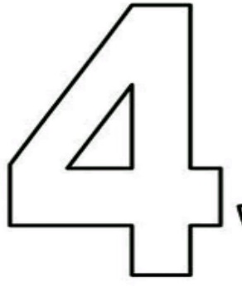

1. Identify the number below

 This is number _________

1. Circle all the number “ ***3*** ” you can inside the star below

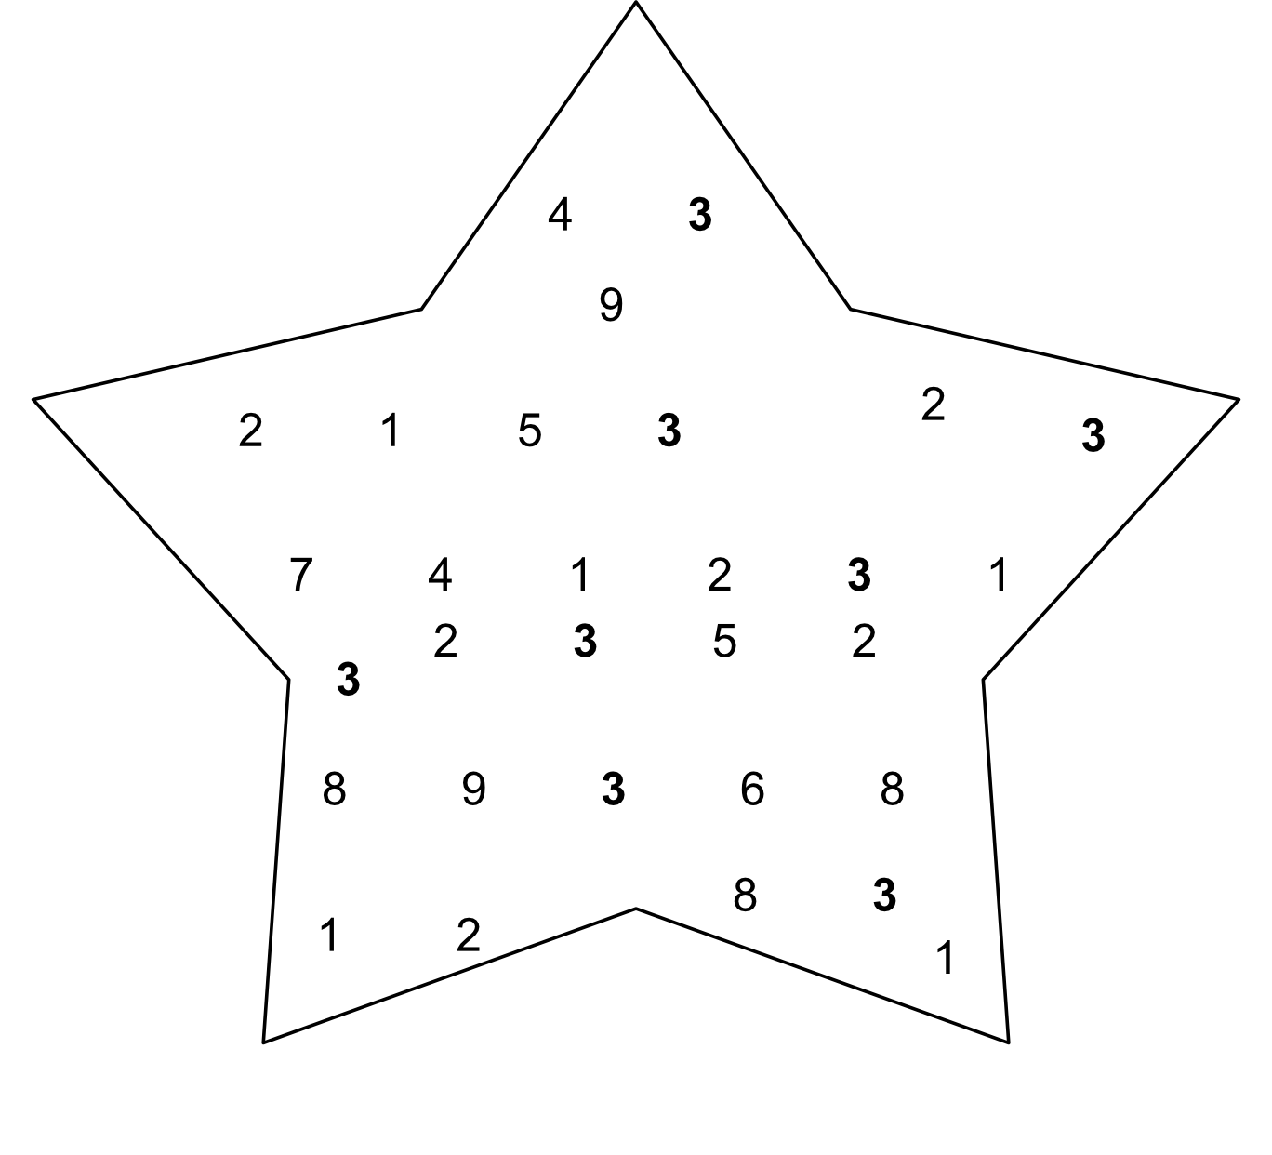

1. Fill in the gaps

1 3

1 2

**PATFIN NURSERY AND PRIMARY SCHOOL, AKESAN, LAGOS STATE.**

**SECOND TERM EXAMINATION**

**CLASS : HEAD – START**

**NAME : __________________________________________ SUBJECT: LETTER – WORK**

**INSTRUCTION : ANSWER CORRECTLY DURATION : 1 HOUR**

1. Sound letters A – I
2. Write letters A – I

____________, ____________, ___________, __________, ___________, ______________, ____________, ____________, ___________,

1. Match same letters

A I

B H

C G

D F

E C

F B

G A

H D

I

1. Match objects to letters

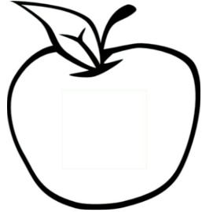 C

 B

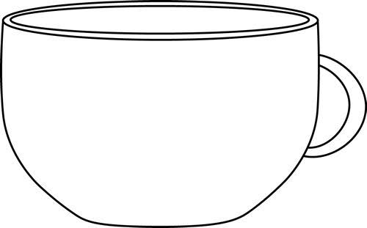 A

 D

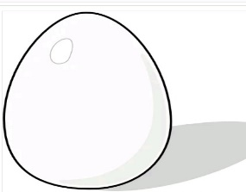 F

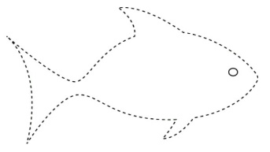 E

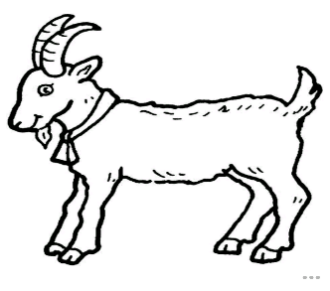 H

 G

**PATFIN NURSERY AND PRIMARY SCHOOL, AKESAN, LAGOS STATE.**

**SECOND TERM EXAMINATION**

**CLASS : K.G 1**

**NAME : __________________________________________ SUBJECT: K . O . W**

**INSTRUCTION : ANSWER CORRECTLY DURATION : 1 HOUR**

1. Yoruba local foods are ______ and _____. [a] Stone and Beans [b] Amala and Ewedu
2. Igbo local foods are ______ and _____. [a] Water and Corn [b] Akpu and Ogbono
3. Hausa local foods are ______ and _____. [a] Ginger and Watermelon [b] Black soup and Tuwo
4. Ten, Ten is a local game . [ Yes / No ]
5. Example of months of the year are

____________, ____________,____________, ____________,

**PATFIN NURSERY AND PRIMARY SCHOOL, AKESAN, LAGOS STATE.**

**SECOND TERM EXAMINATION**

**CLASS : K.G 1**

**NAME : __________________________________________ SUBJECT: K . O . W**

**INSTRUCTION : ANSWER CORRECTLY DURATION : 1 HOUR**

1. Yoruba local foods are ______ and _____. [a] Stone and Beans [b] Amala and Ewedu
2. Igbo local foods are ______ and _____. [a] Water and Corn [b] Akpu and Ogbono
3. Hausa local foods are ______ and _____. [a] Ginger and Watermelon [b] Black soup and Tuwo
4. Ten, Ten is a local game . [ Yes / No ]
5. Example of months of the year are

____________, ____________,____________, ____________,

**PATFIN NURSERY AND PRIMARY SCHOOL, AKESAN, LAGOS STATE.**

**SECOND TERM EXAMINATION [ 2018 / 2019 ]**

**CLASS : RECEPTION**

**NAME : __________________________________________ SUBJECT: COLOURING**

**INSTRUCTION : IDENTIFY THESE OBJECTS DURATION : 1 HOUR**

1. Identify and color



What is this ? It is a ______________________

Color it ________________



What is this ? It is a ______________________

Color it ________________

**PATFIN NURSERY AND PRIMARY SCHOOL, AKESAN, LAGOS STATE.**

**THIRD TERM EXAMINATION [ 2017 / 2018 ]**

**CLASS : HEAD – START**

**NAME : ______________________________________________ SUBJECT: HAND WRITING**

**INSTRUCTION : Write Carefully DURATION : 1 HOUR**

C C C C